VB.Net - If...Then...Else Statement

Section num:3

Syntax:::::

The syntax of an If...Then... statement in VB.Net is as follows:
If(condition)Then
'statement(s) 'will execute if the condition is true
End If
Example 1:
write program that define constant password as string and variable userValue as string then ask user to insert yourpassword, if password = userValue write "you loged in"
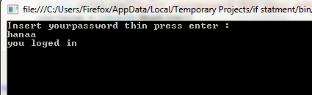
Module Module1
Sub Main()
Const password As String = "hanaa"
Dim userValue As String
Console.WriteLine("Insert yourpassword thin press enter : ")
userValue = Console.ReadLine()
If (password = userValue) Then
Console.WriteLine("you loged in")
End If
Console.ReadLine()
End Sub
End Module

Syntax:::::

The syntax of an If...Then... Else statement in VB.Net is as follows:
If(condition)Then
'statement(s) will execute if the condition is true
Else
'statement(s) will execute if the condition is false
End If
If the condition evaluates to true, then the if block of code will be executed, otherwise else block of code will be executed.

Flow Diagram:
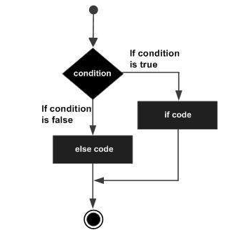
Example 2: write program that define constant password as string and variable userValue as string then ask user to insert your password, if password = userValue write "you loged in" else write "wrong password! Try again" where the output is

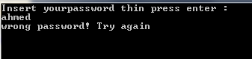

Module Module1
Sub Main()
Const password As String = "hanaa"
Dim userValue As String
Console.WriteLine("Insert yourpassword thin press enter : ")
userValue = Console.ReadLine()
If (password = userValue) Then
Console.WriteLine("you loged in")
Else
Console.WriteLine("wrong password! Try again")

End If
Console.ReadLine()
End Sub

